**→ PYDICOM :**

**(1) Import library’s and read our dataset**

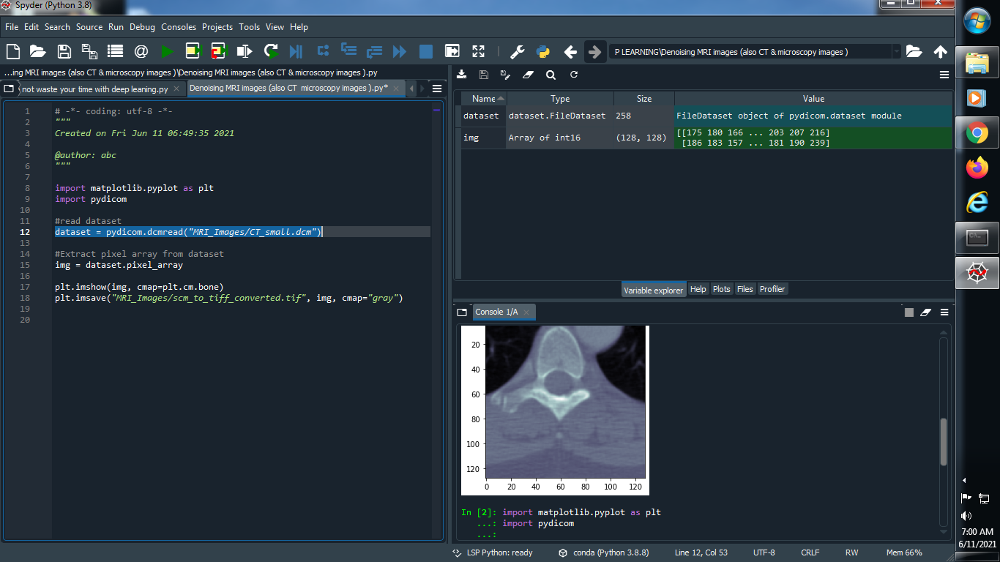

**Output :**



**(2) Extract pixel array from dataset :**

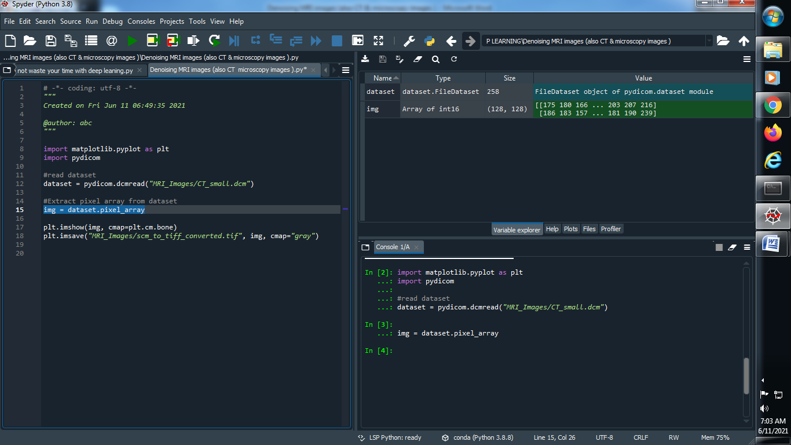

**Output :**



**(3) See our image how it’s look like :**

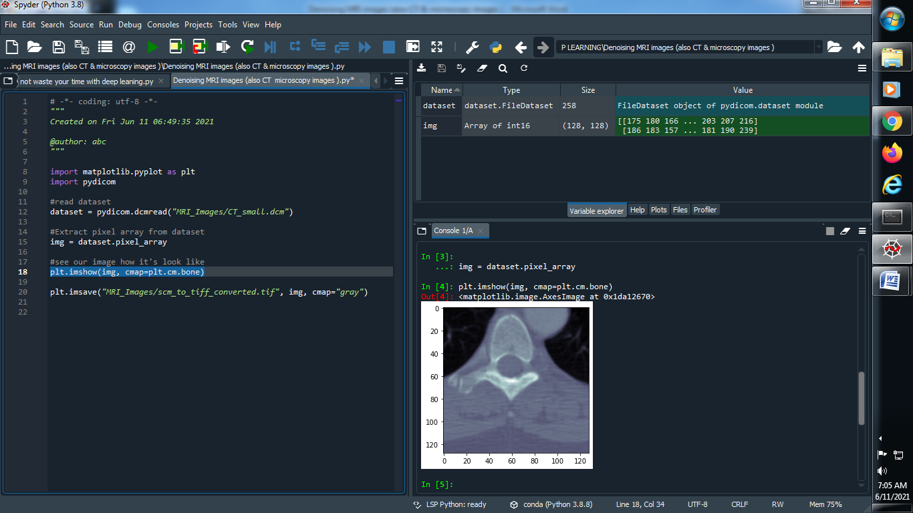

**Output :**



**(4) Save our dataset :**

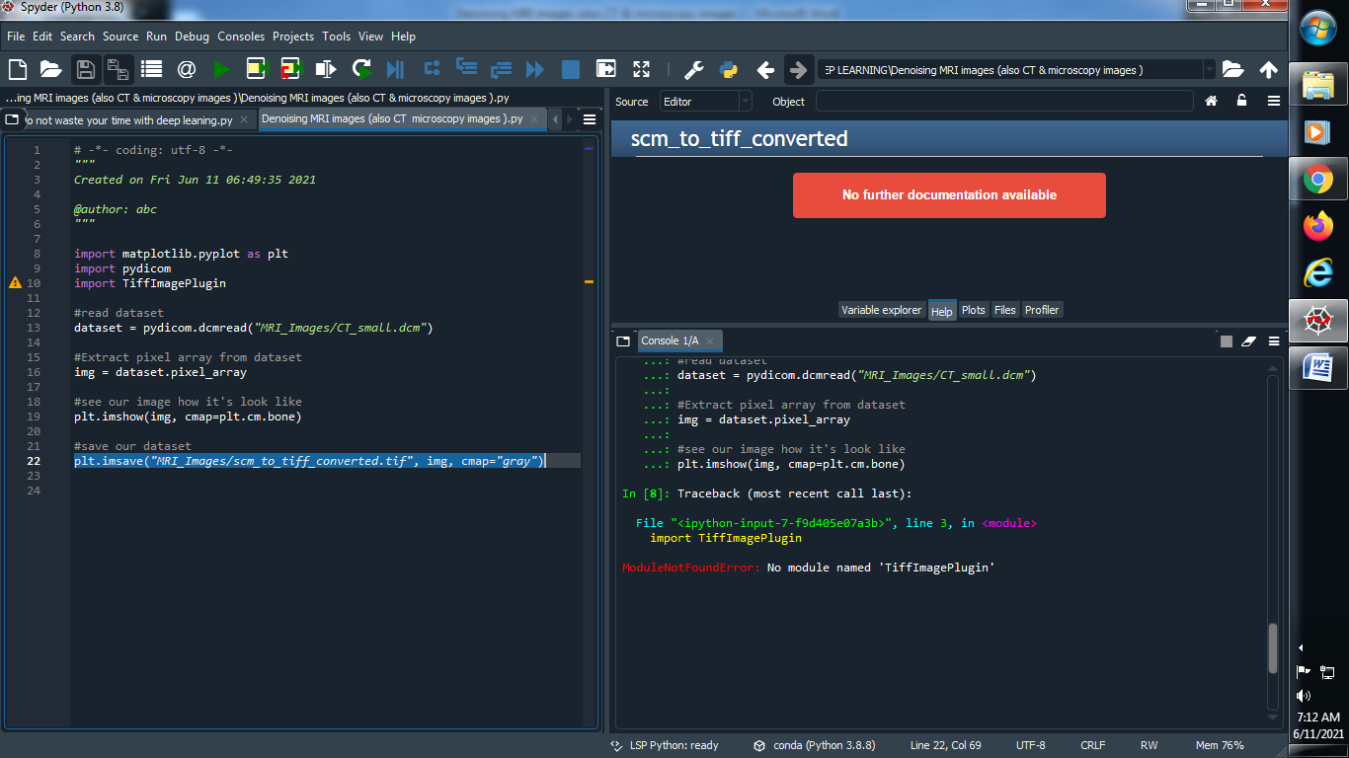

**###############################################################**

**→ Gaussian Filter :**

**(1) Import library’s :**

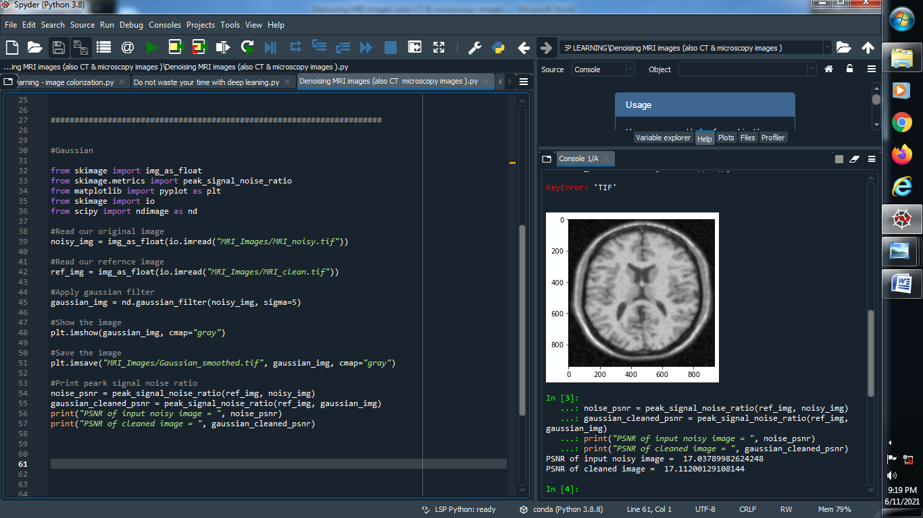

**(2) Read original image and reference image :**

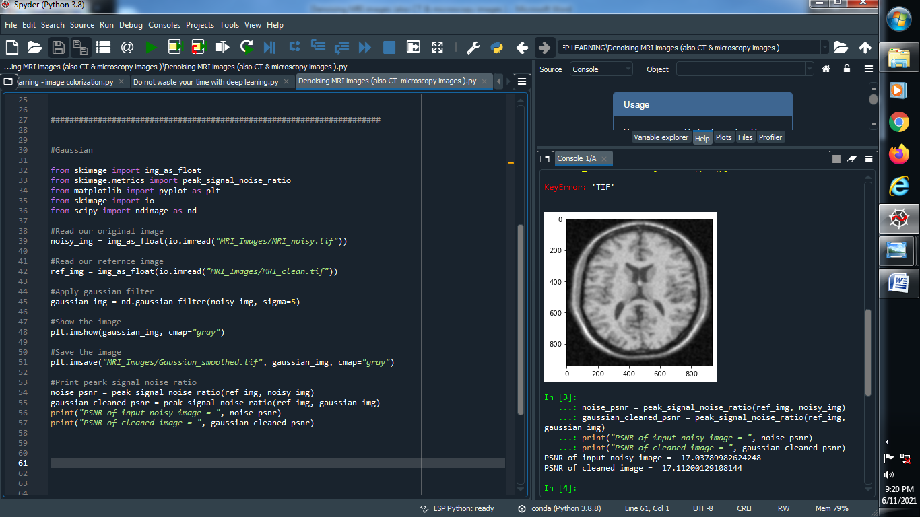

**(3) Apply Gaussian filter :**

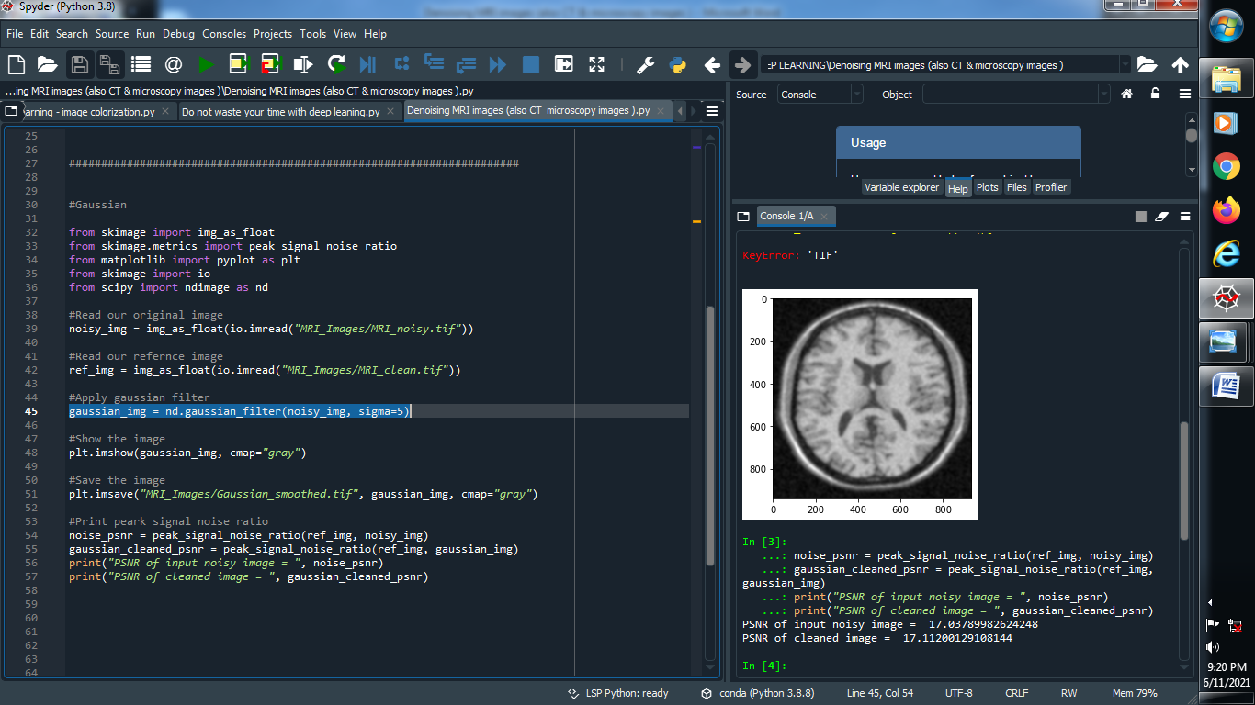

**(4) Show and Save the image :**

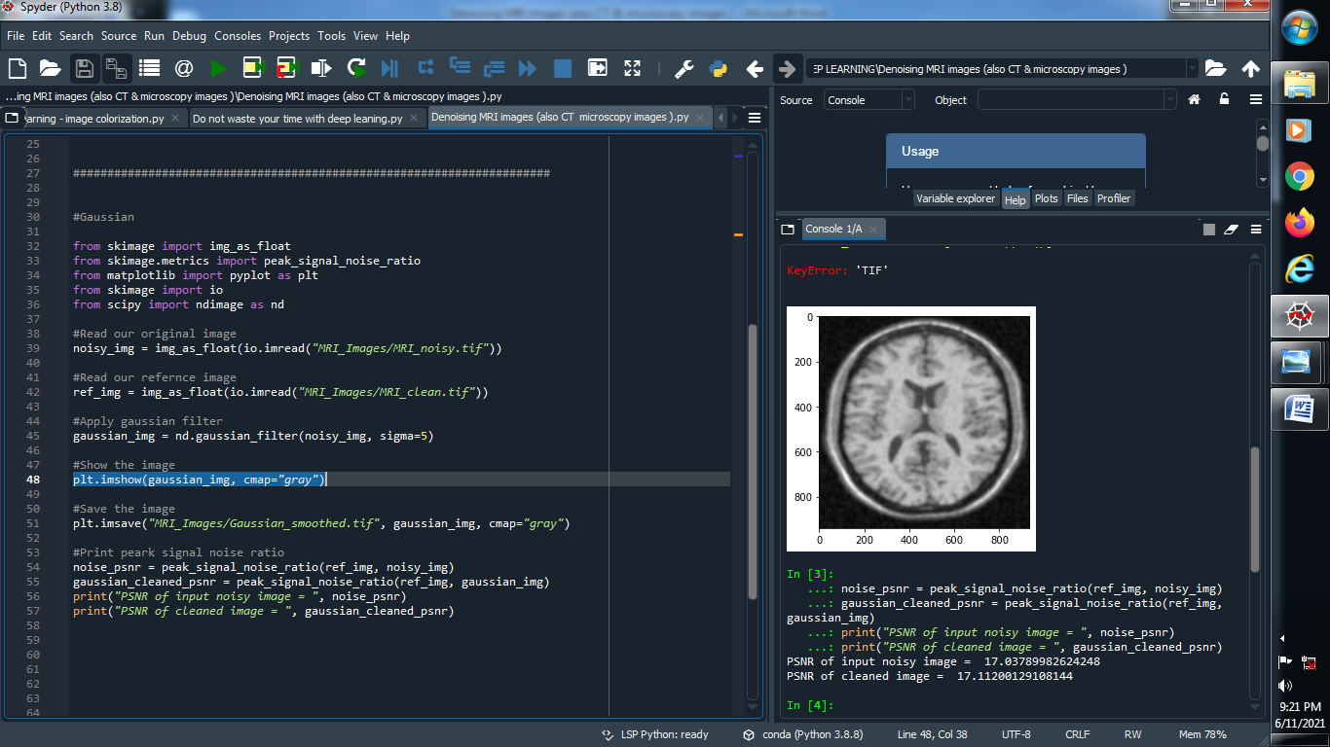

**Output :**

**→ MRI_noisy image : → MRI_clean image :**

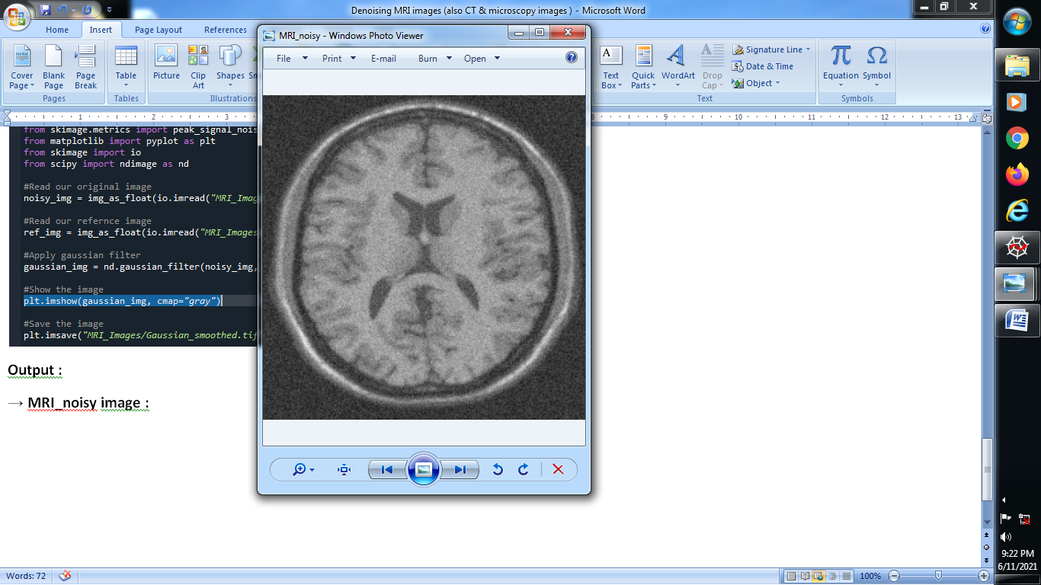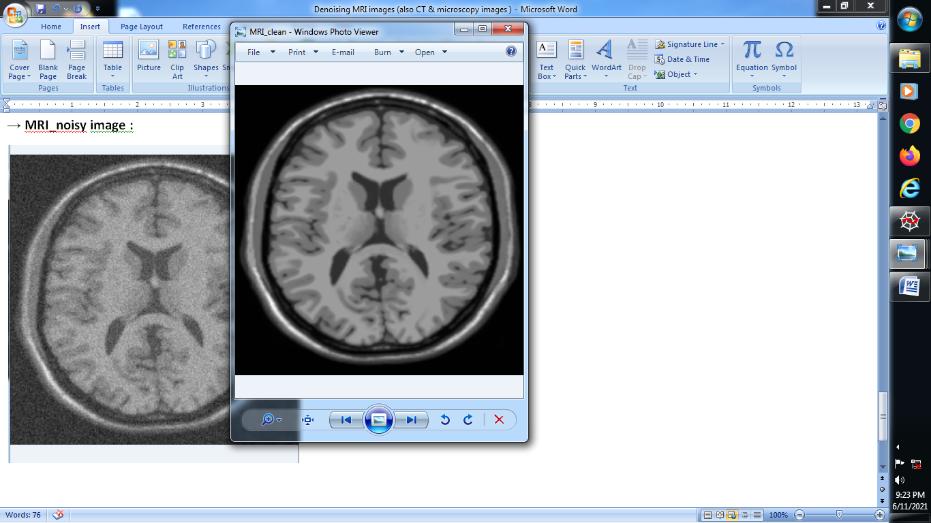

**→ Gaussian image :**

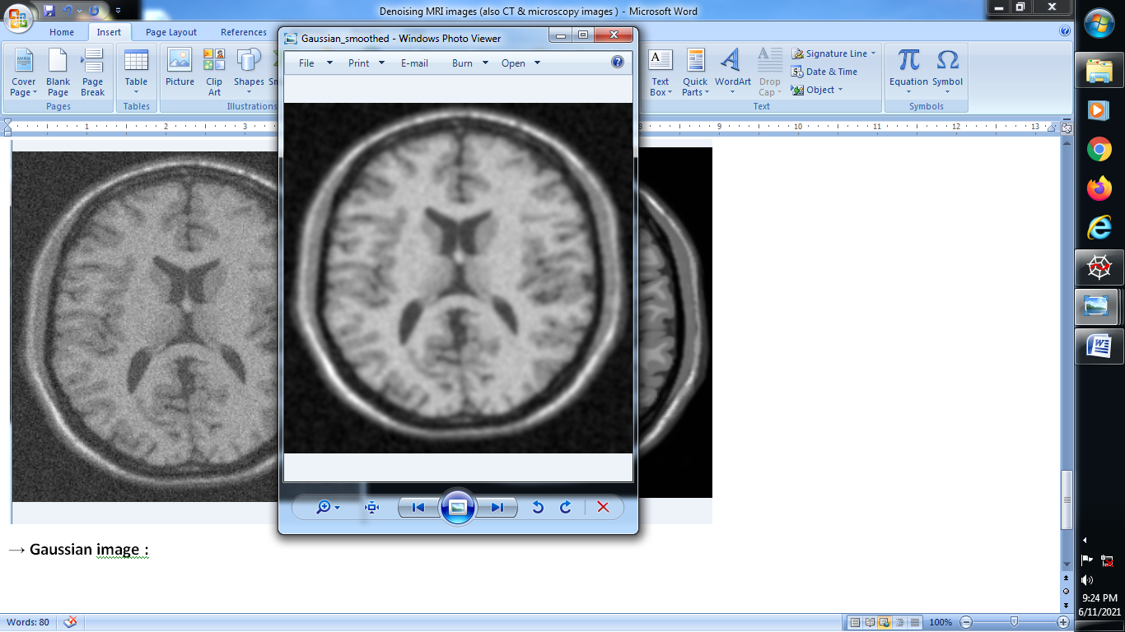

**(5) Print peark signal noise ratio :**

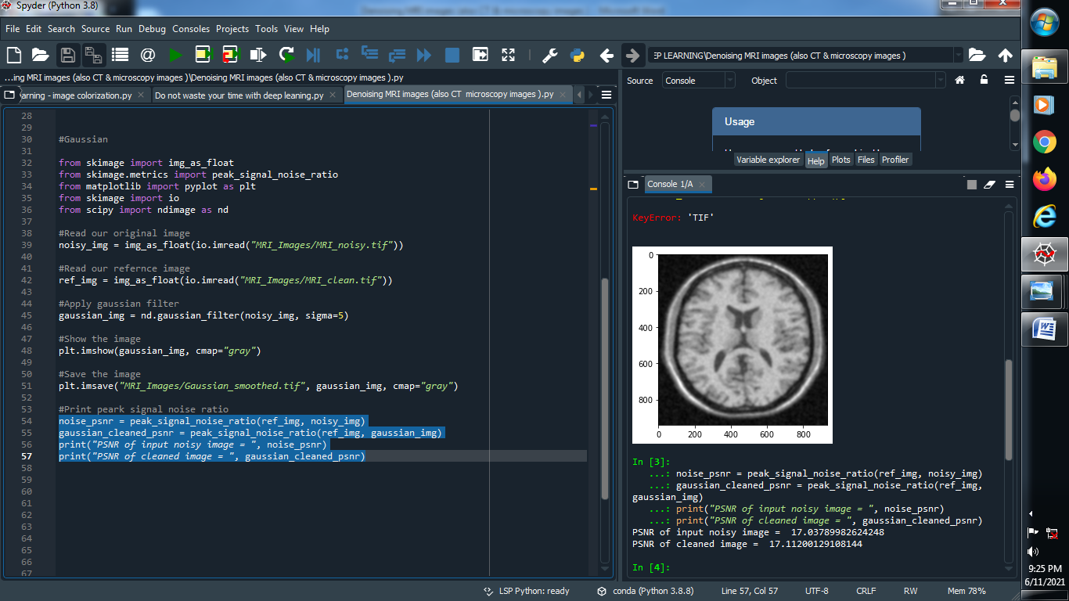

**Output :**

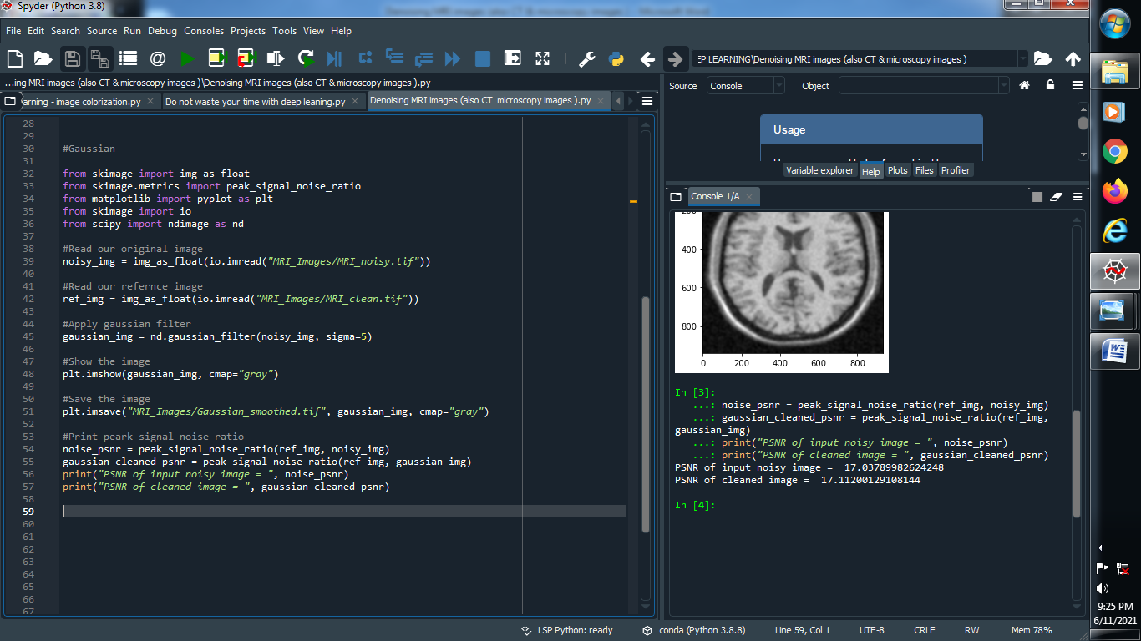

**############################################################################**

**→ Bilateral**

**(1) Import library’s and read original and reference image :**

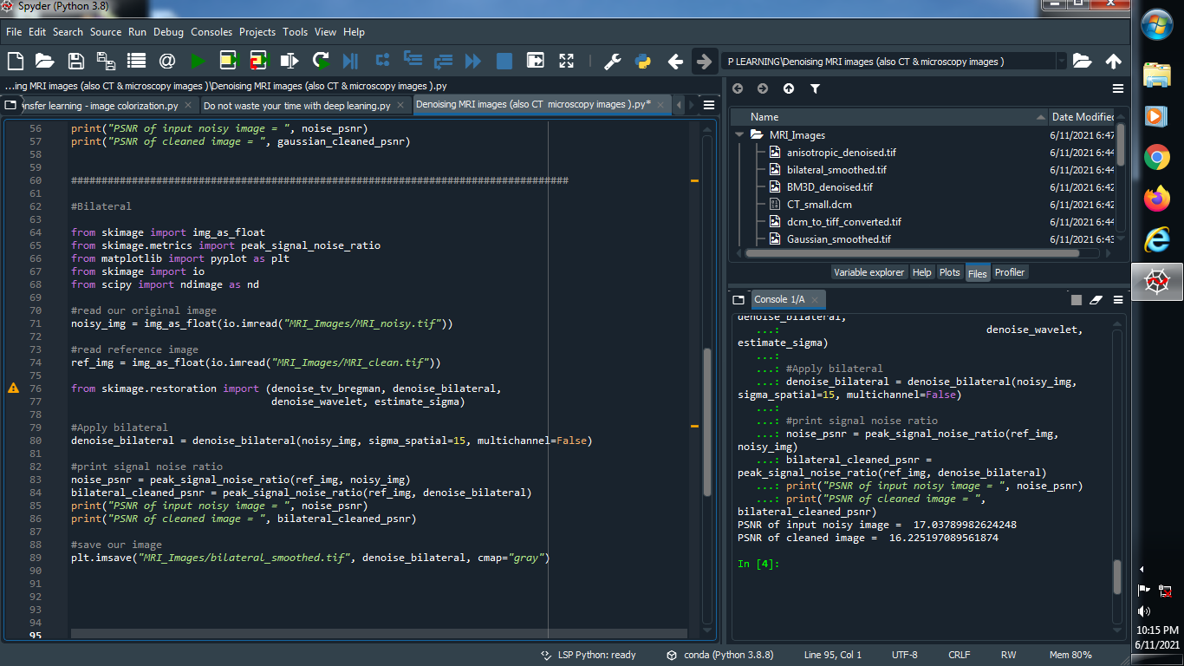

**(2) Apply bilateral noise :**

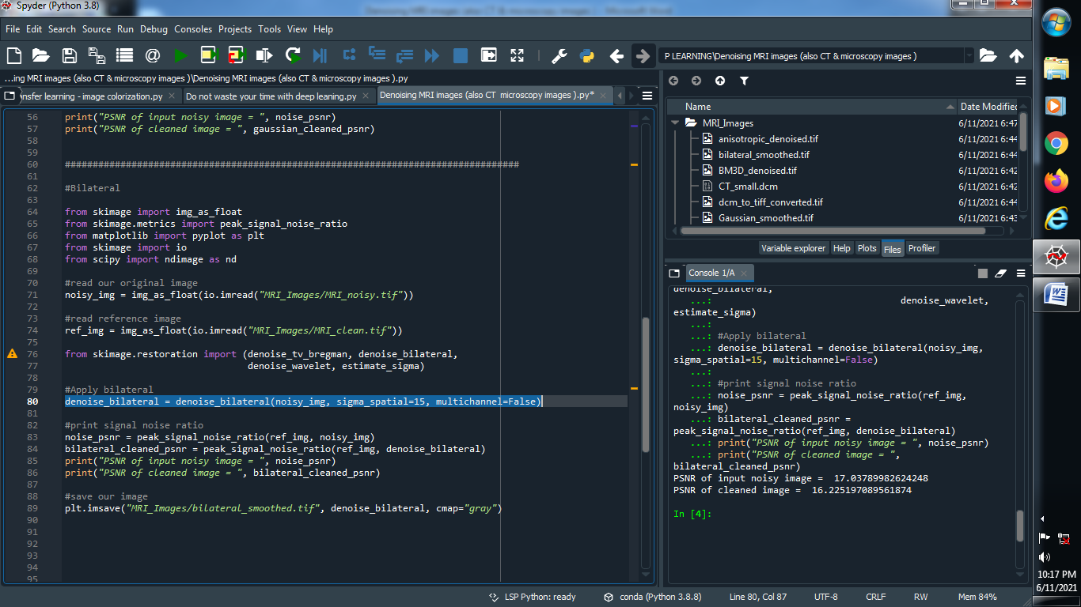

**(3) print signal noise ratio and save our image :**

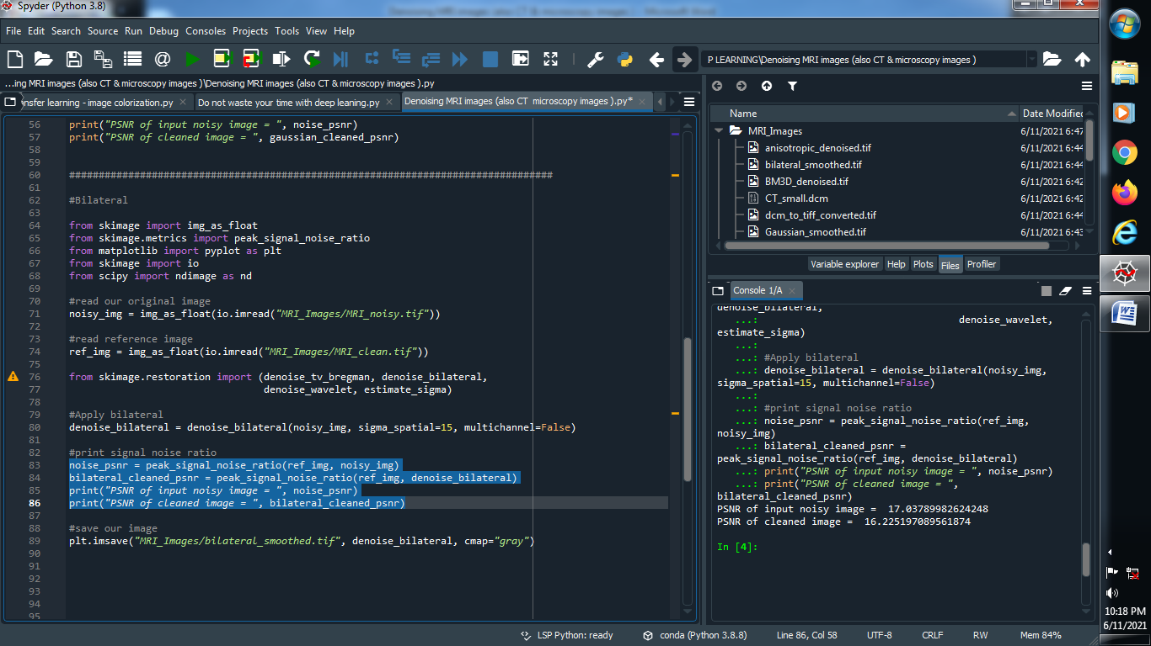

**Output :**



**(4) show the image :**

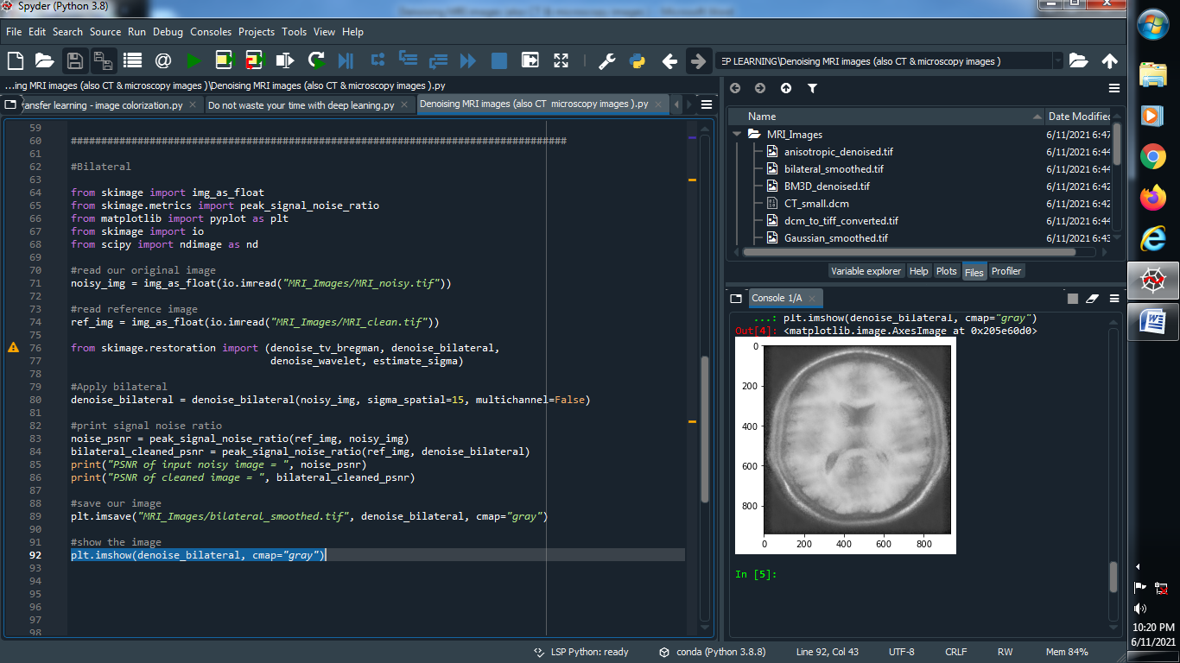

**Output :**

**→ MRI_noisy image : →MRI_clean image :**



**→ Bilateral image :**

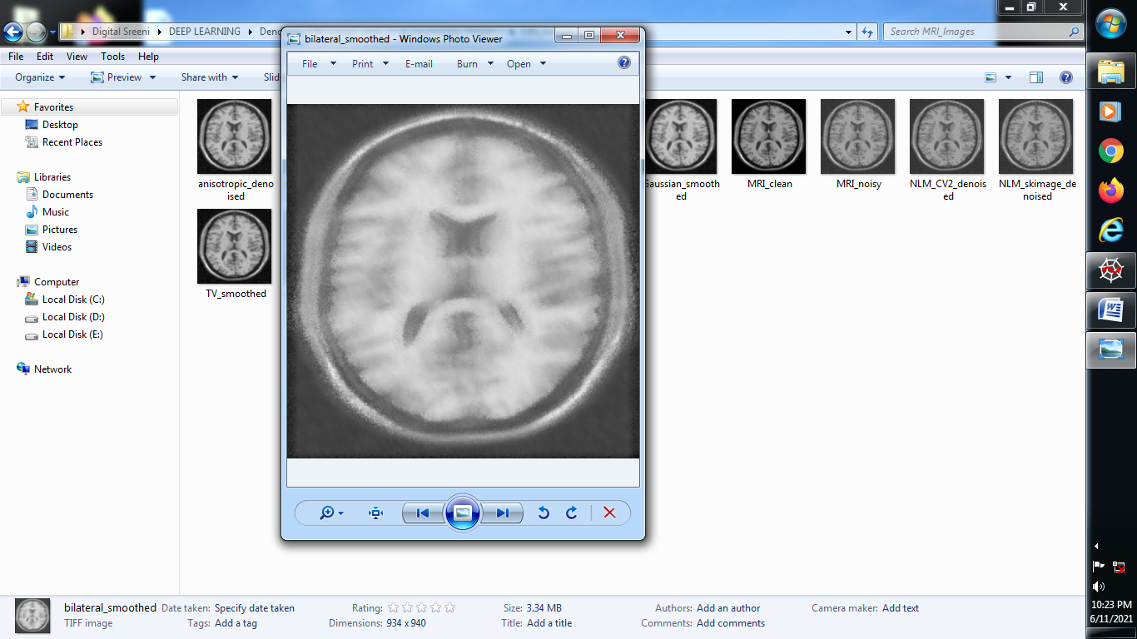

**###################################################################################**

**→ TV Filter :**

**(1) Import library’s and read original and reference image :**

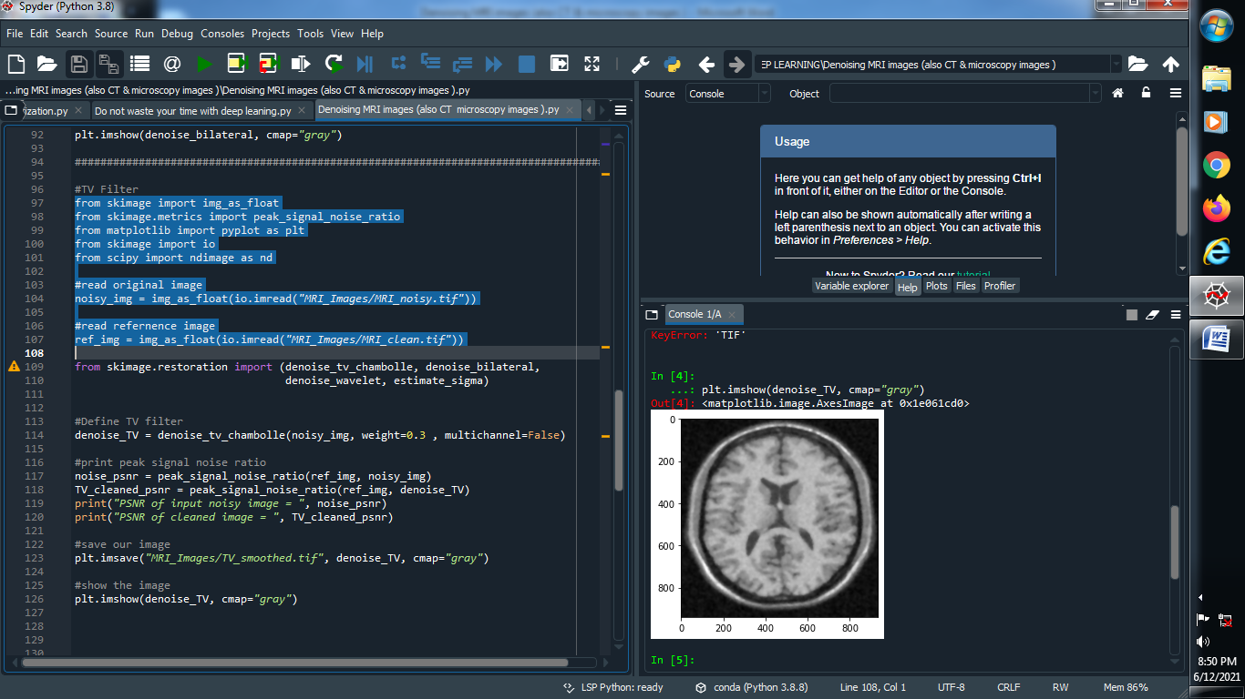

**(2) Define TV Filter :**

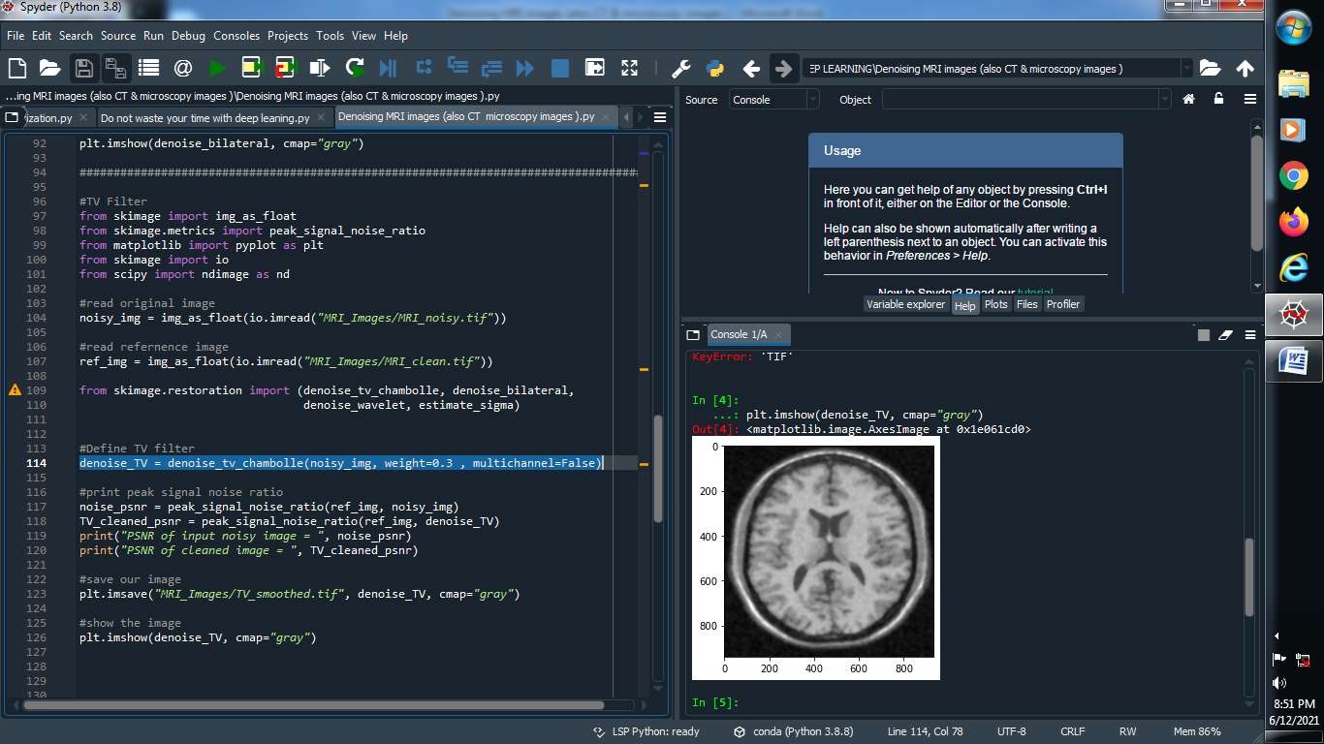

**(3) Print peak signal noise ratio :**

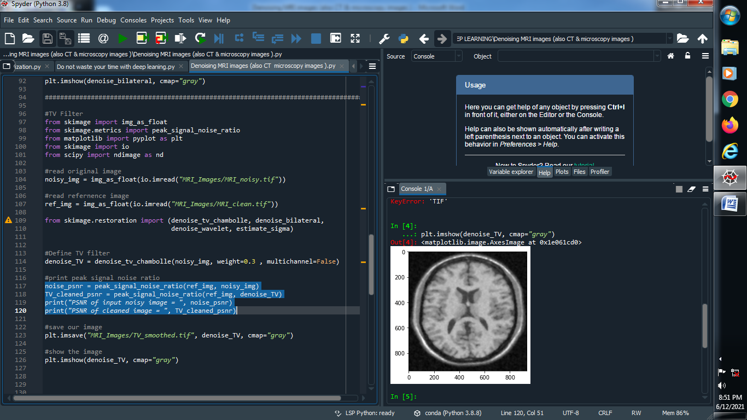

**(4) Save and Show our image :**

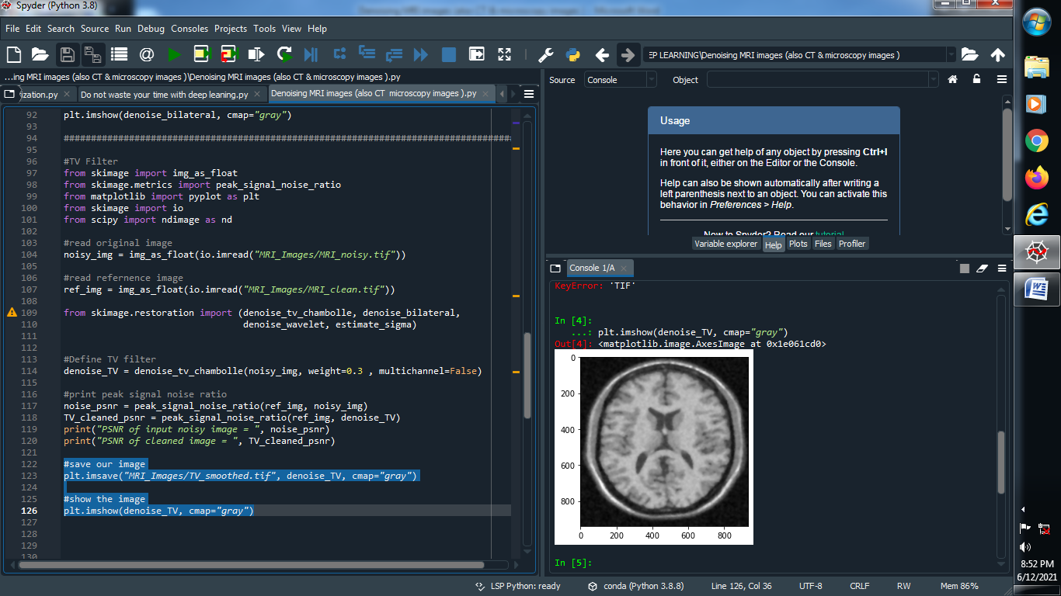

**Output :**

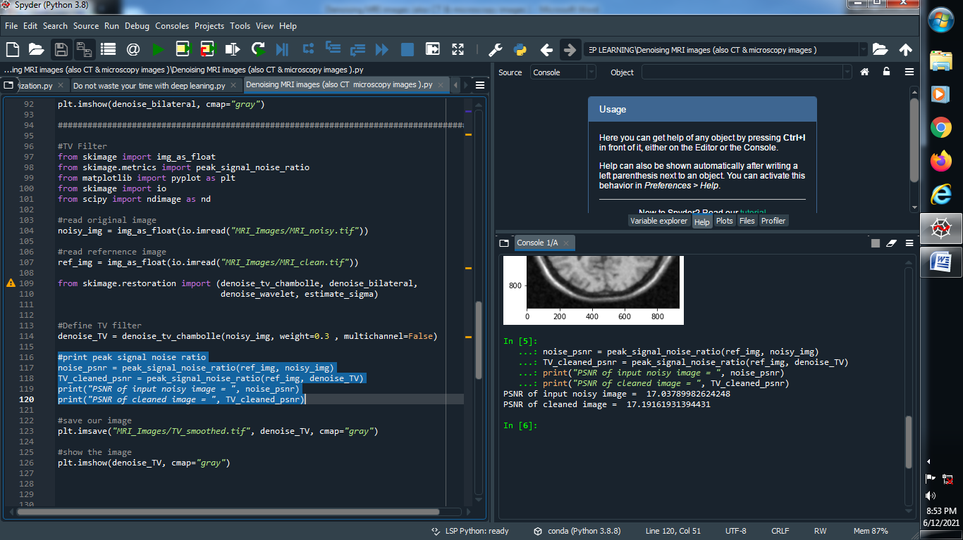

**→ MRI_noisy image : → MRI_clean image :**



**→ TV_Denoise image :**

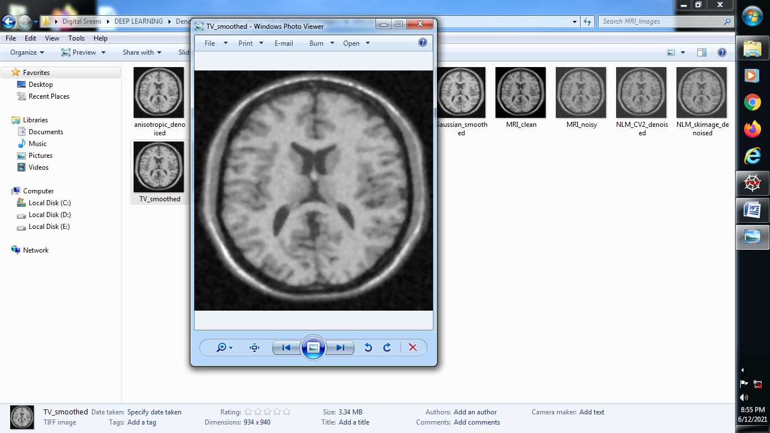

**###########################################################################################**

**→ Wavelet filter :**

**(1) Import library’s and read original image and reference image :**

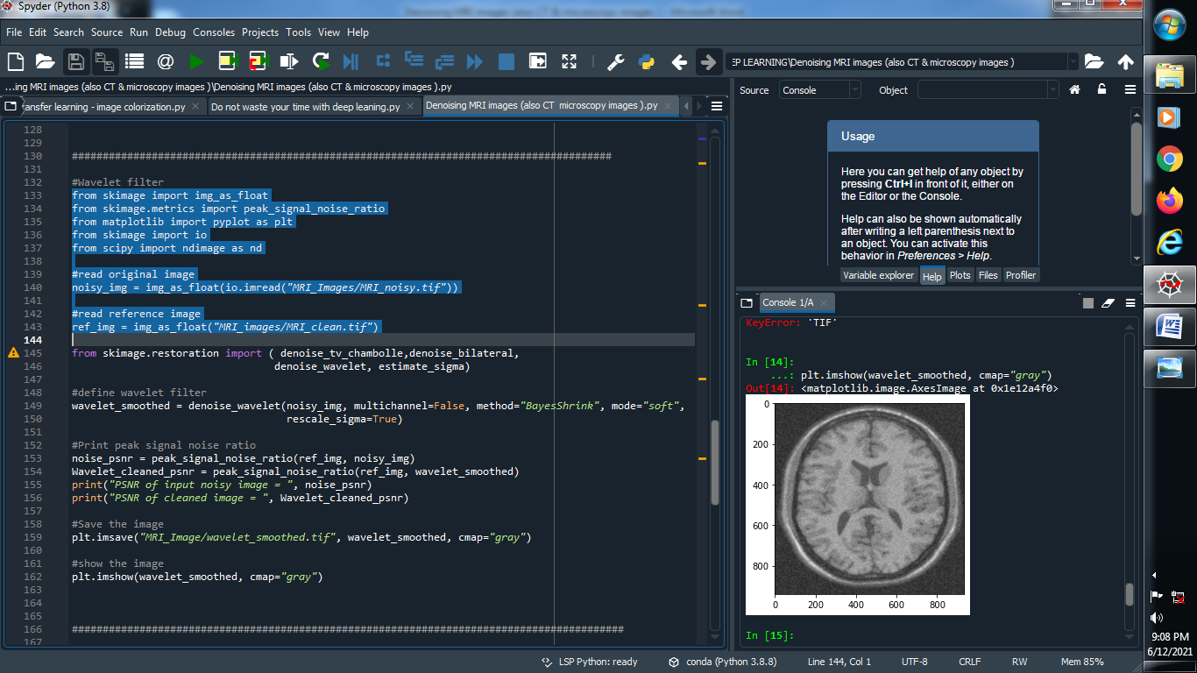

**(2) Define wavelet filter :**

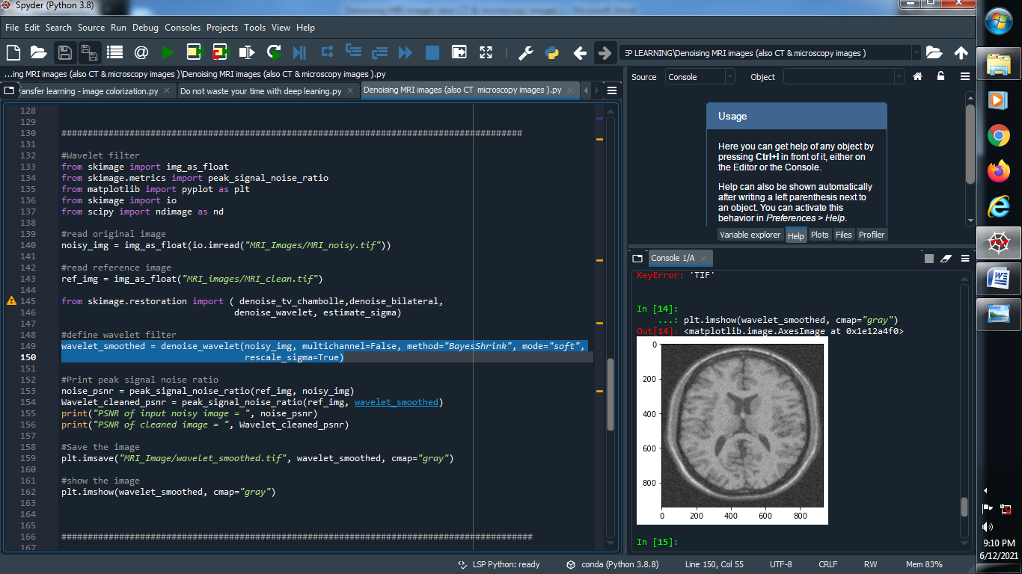

**(3) Print peak signal noisy ratio :**

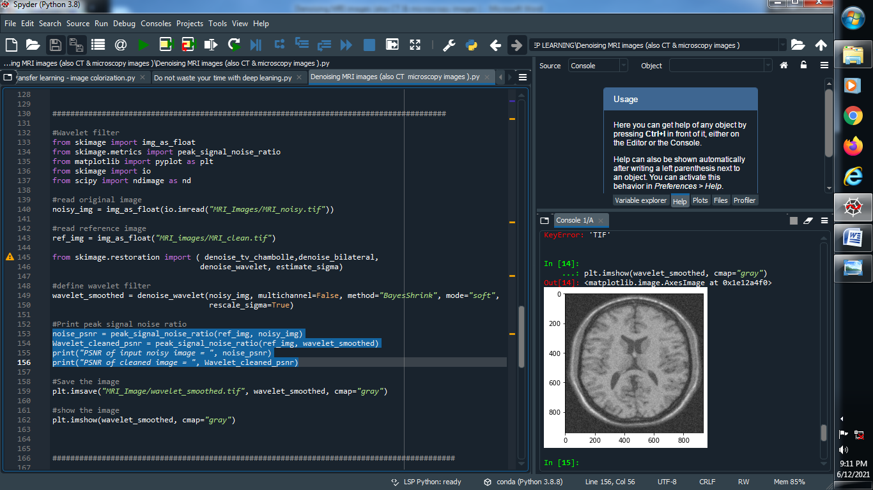

**(4) Save and Show the image :**

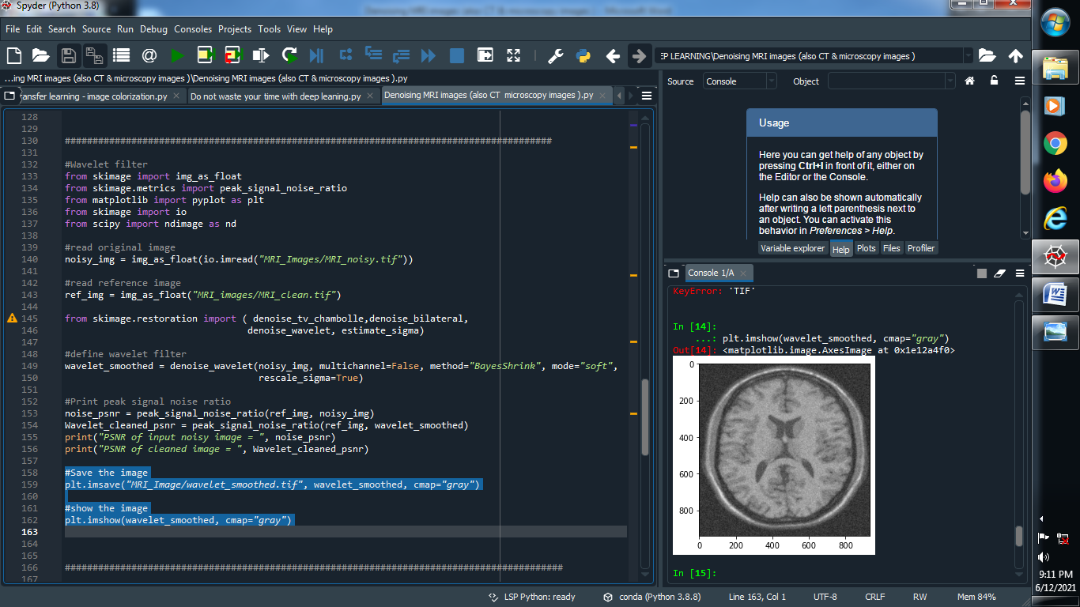

**Output :**

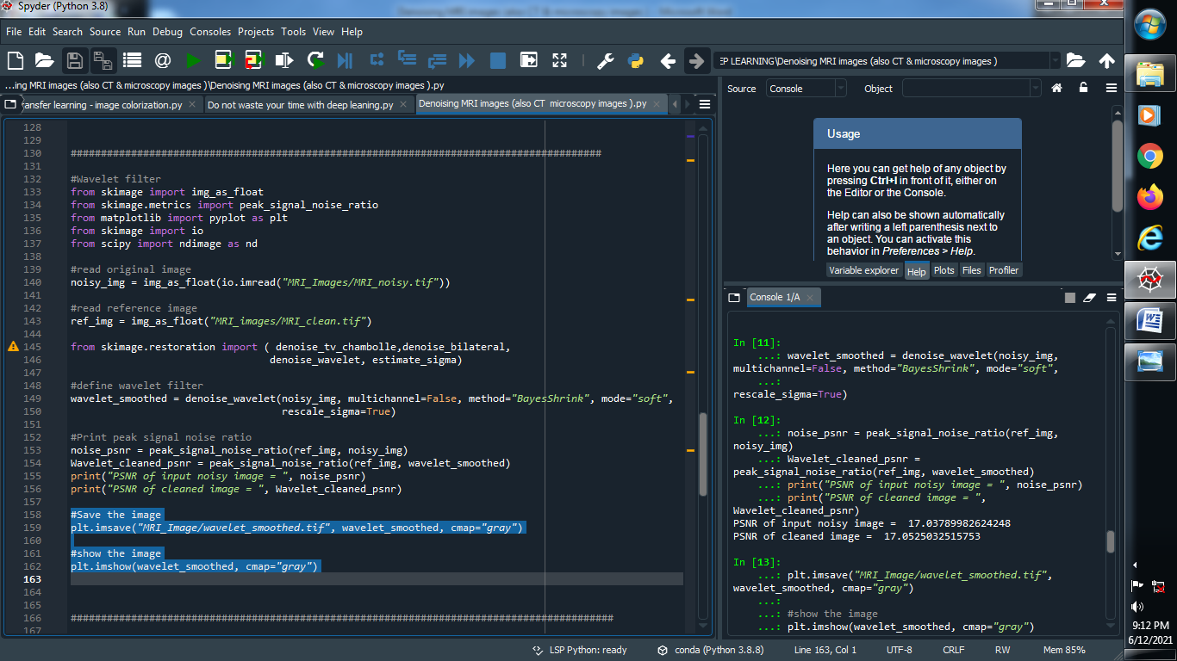

**→ MRI_noisy image : → MRI_clean image :**



**→ Wavelet_smoothed image :**

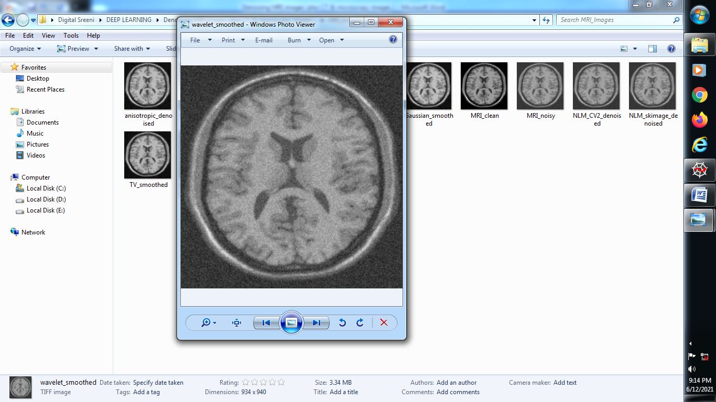

**#######################################################################**

**→ Anisotropic denoise filter :**

**(1) Importing library’s and read original image and reference image :**

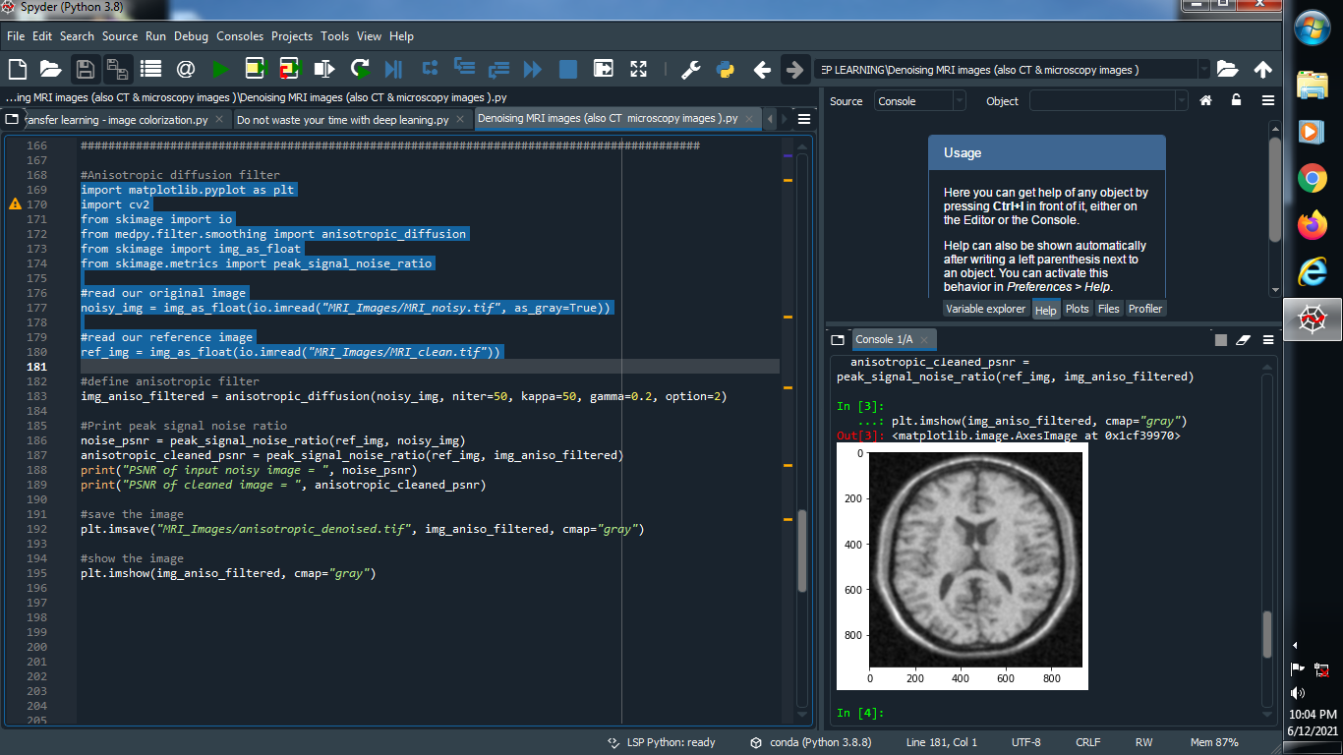

**(2) Print peak signal noise ratio :**